To comply with federal Environmental Protection Agency (EPA) regulations, public water systems are required to complete an inventory of customer service lines. This survey plays a vital role in helping your public water system fulfill this obligation effectively. The following information will help you determine what your water service line is made of.

Find Your Water Service Line
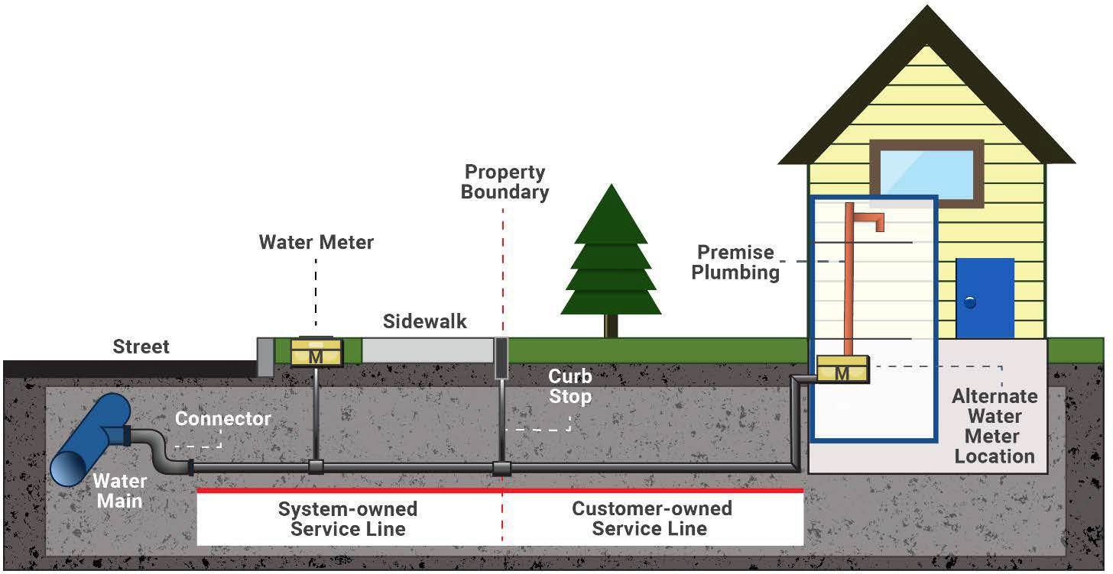
Before completing the survey, you need to determine where your water service line is and how it connects to your home. If you need assistance finding your service line, contact your public water system at click here to enter water system contact info.

Outside Meter or Curb Stop
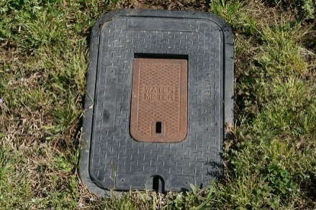
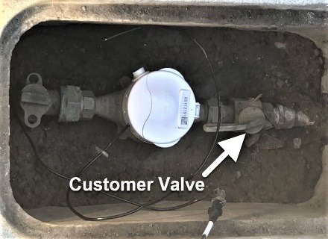
To locate where the water service line enters your home, look for a water meter and curb stop valve. These are usually found at the front of your property near the street or sidewalk and are ground-level boxes labeled "water" or "meter." Once you find them, follow the shortest path to your home. The water service line should enter the building through the floor or foundation wall in this general area.

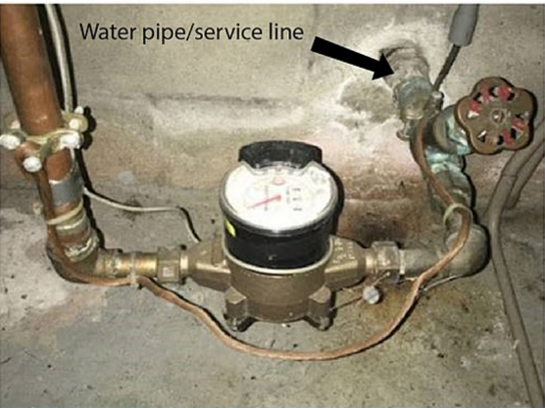
Test the Pipe Material
Once you've found where the water service line enters your home, look for a spot on the pipe closest to the wall or floor before it connects to a valve or meter. At this spot, you can test the material the pipe is made of. It is important to find the pipe entering your home.

Testing Tools
Use the following tools to determine the type of pipe material the water service line is made of.
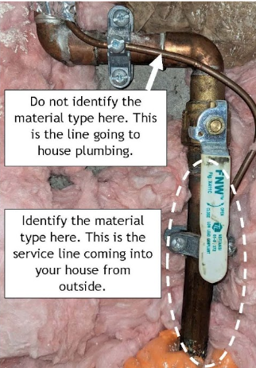
- Refrigerator magnet or other magnet—use to test if the pipe is made of steel or iron.
- Screwdriver or coin—use to scratch the pipe to reveal the metal’s color and hardness and tap for sound.
- Flashlight or mobile phone—light to clearly see the pipe.
- Lead—Scratch Test: Easily scratched. If the scraped area is shiny and silver, the pipe is lead. Magnet Test: A magnet will not stick to a lead pipe. Tapping Test: Tapping a lead pipe with a coin will produce a dull noise.
- Copper—Scratch Test: If the scraped area is copper in color, like a penny, the pipe is copper. Magnet Test: A magnet will not stick to a copper pipe. Tapping Test: Tapping a copper pipe with a coin will produce a metallic ringing noise.
- Galvanized Steel or Iron—Scratch Test. If the scraped area remains a dull gray, the pipe is galvanized steel. Magnet Test: A magnet sticks to a galvanized pipe. Tapping Test: Tapping a galvanized pipe with a coin will produce a metallic ringing noise.
- Plastic—This pipe comes in different materials and colors. The pipe does not make a ringing sound when tapped with a coin or screwdriver.
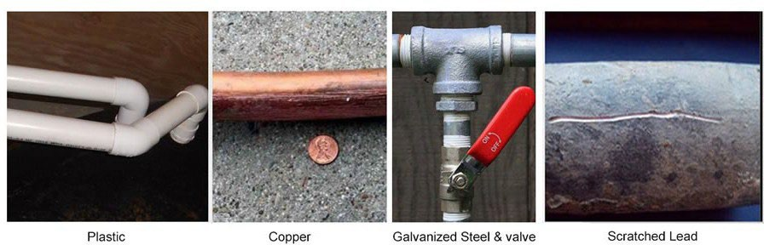

Customer Water Line Service Survey

Location Information
Address: Click here to enter text.
City: Click here to enter text. | Zip Code: Click here to enter text.

Please answer the following questions.
Do you own or rent this building? |  | ☐ Own |  | ☐ Rent
What year was the building built? Click here to enter text.
To your knowledge, has the water service line for your building ever been replaced?
☐ Yes | What year was it replaced? Click here to enter text.
☐ No
☐ Not sure
What material is your water service line? You may choose more than one.
☐ Lead |  |  | ☐ Copper
☐ Steel (ductile iron pipe, galvanized) |  |  | ☐ Plastic (HDPE, PVC)
☐ Unknown |  |  | ☐ Cannot locate service line
How did you determine the material? Choose one.
☐ Scratch test |  |  | ☐ Visual
☐ Cannot locate service line |  |  | ☐ Plumber or other qualified professional
Thank you. Please return your survey to the following representative.

Enter water system contact info.

For More Information
Find more resources on our Lead Service Line Inventory—EPA's Lead and Copper Rule Revisions webpage.

Public Water System Webpage Address
Enter water system website URL here.

To request this document in another format, call 1-800-525-0127. Deaf or hard of hearing customers, please call 711 (Washington Relay) or email doh.information@doh.wa.gov. If in need of translation services, call 1-800-525-0127.

